**Lab report 9**



**Data communication and network lab**

**Submitted by: Muhammad Ali**

**Registration No: 19pwcse1801**

**Class Section: A**

**Submitted to: Sir Faiz Ullah**

**Date: 1/07/2022**

**University of Engineering and Technology, Peshawar**

**Department of Computer Systems Engineering**

**LAB # 9**

**TCP/IP Implementation using Python Socket Programming**

|  |  |  |
| --- | --- | --- |
| **Criteria** | **Excellent** | **Marks Obtained** |
| 1. **Objectives of Lab** | All objectives of lab are properly covered  [Marks 0.5] |  |
| 1. **Introduction to Python Programming** | Brief introduction of Python Programming  [Marks 2] |  |
| 1. **Introduction to python socket library and its various functions** | Brief introduction about Socket library and its various functions used in Lab  [Marks 2] |  |
| 1. **Client-Server Communication using socket library** | Client-Server communication, Python code and output  [Marks 3] |  |
| 1. **Flowchart of client server communication using python socket library** | Draw a flowchart of  the sequence of socket API calls and data flow for TCP  [Marks 2] |  |
| 1. **Conclusion** | Conclusion about RC-Circuit analysis  [Marks 0.5] |  |

**Objective:**

* To understand python programing basic.
* To learn socket based library client-server communication**.**

**Intro python: -**

Python is a popular programming language. It was created by Guido van Rossum, and released in 1991.

**It is used for:**

* web development (server-side),
* software development,
* mathematics,
* system scripting.

**Features: -**

* Python was designed for readability, and has some similarities to the English language with influence from mathematics.
* Python uses new lines to complete a command, as opposed to other programming languages which often use semicolons or parentheses.
* Python relies on indentation, using whitespace, to define scope; such as the scope of loops, functions and classes. Other programming languages often use curly-brackets for this purpose.

**Socket library intro: -**

Python's standard library consists of various built-in modules that support interprocess communication and networking. The network access is available at two levels. The 'socket' module defines how server and client machines can communicate at hardware level using socket endpoints on top of the operating system. The 'socket' API supports both connection-oriented and connectionless network protocols. The higher level support is available in Python libraries such as ftplib and httplib, implementing Application level network protocols FTP and HTTP respectively. This chapter takes a look at the functionality of 'socket' module that provides access to BSD socket interface.

**Client python program: -**

import socket

s = socket.socket(socket.AF_INET,socket.SOCK_STREAM)

s.connect((socket.gethostname(),6061))

while (1):

msg = s.recv(2048)

print ('message recieved: ',msg.decode())

**Output: -**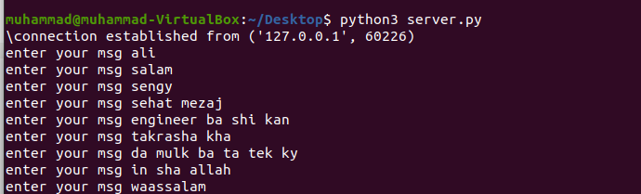

**Server python program: -**

import socket

msg_end =''

s = socket.socket(socket.AF_INET,socket.SOCK_STREAM)

s.bind((socket.gethostname(),6061))

s.listen(5)

clientSocket, address = s.accept()

print("\connection established from",address)

while (1):

if msg_end != "end":

msg = input("enter your msg ")

clientSocket.send(bytes(msg,'utf-8'))

msg_end = msg

else:

clientSocket.close()

**Output: -**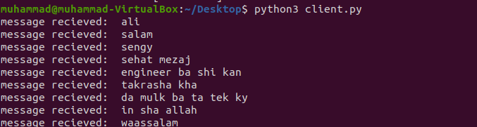

**Conclusion: -**

After describing both client server processes in python programing, I have established successful path for communication b/t client and server using socket library.